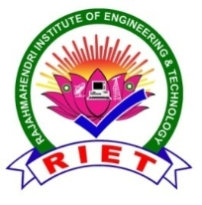 | 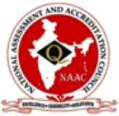  RAJAMAHENDRI  INSTITUTE OF ENGINEERING & TECHNOLOGY  (Approved by AICTE, New Delhi, Affiliated to JNTUK, Kakinada, Accredited BY NAAC)  BHOOPALAPATNAM, RAJAMAHENDRAVARAM, E.G. Dist., AP, 533107.  eMail: office@rietrjy.co.in Website: www.rietrjy.co.in Ph: +91 91212 14413

Divyangjan Policy

Physical limitations should not be a barrier for students at RIET, which beliefs in quality education at all levels. Regardless of physical impairments, the College encourages students to pursue higher education. The Divyangjan Policy seeks to enhance the right to education via the implementation of several government-mandated and volunteer actions.
RIET provides the following amenities for the benefit of DIVYANGJAN:
- Ramp/Rail: Our institution provides a barrier-free environment in important buildings for differently-abled students. Ramp/rail is sited at the main entrance and exit of the building, where any disabled student can easily identify and access it. The ramp is so wide that a wheelchair user can use it without any problem.

- Accessible Toilets: Large floor space is provided for a student who can easily move about. The floor surface is slip-resistant. A separate toilet is available for people with different disabilities.

- e-Classroom: For uninterrupted studies for Divyangjan students, our institution has provided an e-classroom on campus.

- Scribes for Examination: Our institution shall provide or allows scribers for those students who are in need while writing exams. Controller of Examinations shall allow the student on the recommendations of the Principal to grant extra time to disabled candidates for answering papers at University examinations. Extra time up to 20 mins per hour can be given to complete the paper.

- In the case of students who are eligible to avail of the services of scribes, the Principal shall authorize the appointment of scribes according to the following conditions.
- The scribe shall not be an employee of the college/centre where the examination is conducted.
- The scribe shall not be a relative of the student who is appearing for the examination.
- The educational qualifications of the scribe shall be less than those of the student.
- A proforma with the declaration in the format given institute shall be obtained from the scribe. The proforma signed by the scribe shall be forwarded to the institute.

